Magnetic Contact

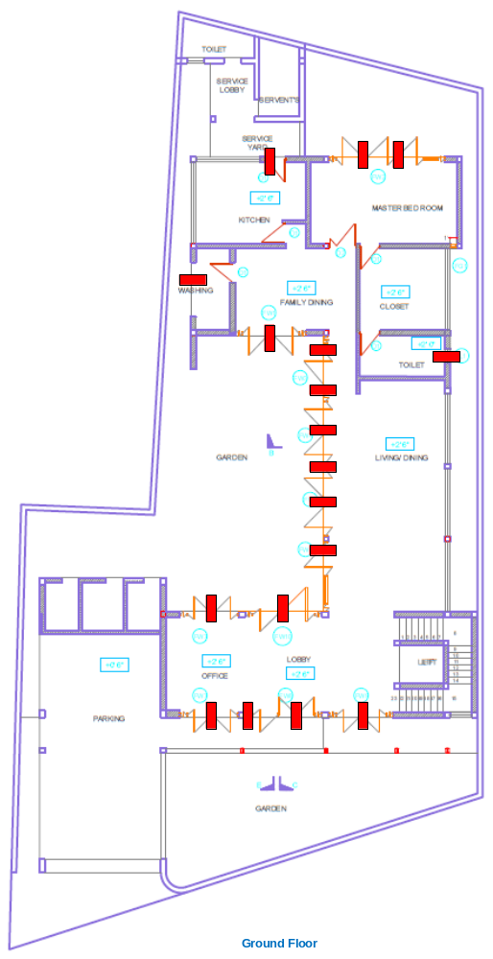

Customer Name | Mr. Lakshman Kottage
Drawing Title | IDS - GF
Issue No | RE/TE
Issue Date | 12/5/2019
Revision No
Revision Date
Created By | Ajith Fernando
Approved By

